Machine learning Lab Observation
ITA0614

Experiment 5

Implementation of K-Nearest Neighbours (K-NN) in Python

Name : Sakthi K S
Reg.No : 192412247

PROBLEM 1: FRUIT QUALITY CLASSIFICATION
AIM
To implement the K-Nearest Neighbours (K-NN) algorithm in Python and classify a fruit as Fresh or Spoiled based on its weight, sweetness and firmness.
ALGORITHM
- Start the program.
- Import the required Python libraries.
- Create the training dataset containing fruit weight, sweetness and firmness.
- Separate the input features and target class.
- Scale the input features using StandardScaler.
- Choose the value of K = 3.
- Train the K-NN classifier using the training dataset.
- Give a new fruit sample as input.
- Calculate the distance between the new sample and the training samples.
- Select the three nearest neighbours.
- Determine the class based on majority voting.
- Display the predicted class.
- Stop the program.
Program:
import numpy as np
from sklearn.neighbors import KNeighborsClassifier
from sklearn.preprocessing import StandardScaler
X = np.array([
[150, 12, 8],
[170, 13, 7],
[140, 10, 6],
[220, 8, 3],
[200, 9, 4],
[230, 7, 2],
[160, 12, 7],
[210, 8, 3]
])
y = np.array([
"Fresh", "Fresh", "Fresh", "Spoiled",
"Spoiled", "Spoiled", "Fresh", "Spoiled"
])
scaler = StandardScaler()
X_scaled = scaler.fit_transform(X)
model = KNeighborsClassifier(n_neighbors=3)
model.fit(X_scaled, y)
new_sample = np.array([[165, 12, 7]])
new_scaled = scaler.transform(new_sample)
prediction = model.predict(new_scaled)
print("Predicted Class:", prediction[0])

Input
Training data set:
Weight (g) | Sweetness (Brix) | Firmness | Quality
150 | 12 | 8 | Fresh
170 | 13 | 7 | Fresh
140 | 10 | 6 | Fresh
220 | 8 | 3 | Spoiled
200 | 9 | 4 | Spoiled
230 | 7 | 2 | Spoiled
160 | 12 | 7 | Fresh
210 | 8 | 3 | Spoiled
New Sample: [165, 12, 7]
Output
Predicted Class: Fresh
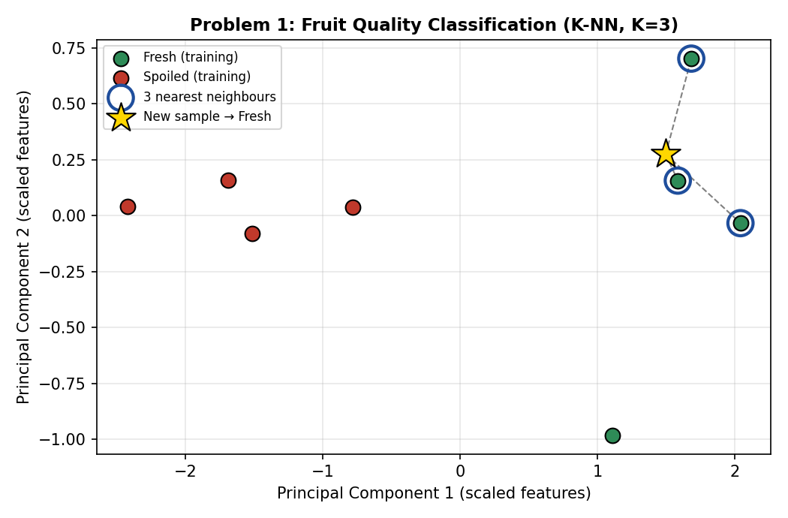
Result
Thus, the K-Nearest Neighbours algorithm was implemented successfully in Python and the given fruit sample was classified as Fresh.

Problem 2: BATTERY HEALTH CLASSIFICATION
AIM
To implement the K-Nearest Neighbours (K-NN) algorithm in Python and classify the health condition of a battery as Healthy or Weak based on voltage, internal resistance and charge cycles.
ALGORITHM
- Start the program.
- Import NumPy, K-NN and StandardScaler.
- Create the battery training dataset.
- Separate the input features and target labels.
- Standardize the input features.
- Select K = 3.
- Train the K-NN model.
- Provide the new battery measurements.
- Calculate the distance from the new sample to all training samples.
- Select the three nearest samples.
- Perform majority voting.
- Display the predicted battery health.
- Stop.
PROGRAM
INPUT
Voltage (V) | Resistance (mΩ) | Cycles | Health
4.10 | 45 | 200 | Healthy
4.00 | 50 | 250 | Healthy
4.15 | 42 | 180 | Healthy
3.60 | 95 | 500 | Weak
3.70 | 85 | 450 | Weak
3.50 | 110 | 600 | Weak
4.05 | 48 | 220 | Healthy
3.65 | 100 | 550 | Weak
New Sample: [4.0, 52, 240]
OUTPUT
Predicted Class: Healthy
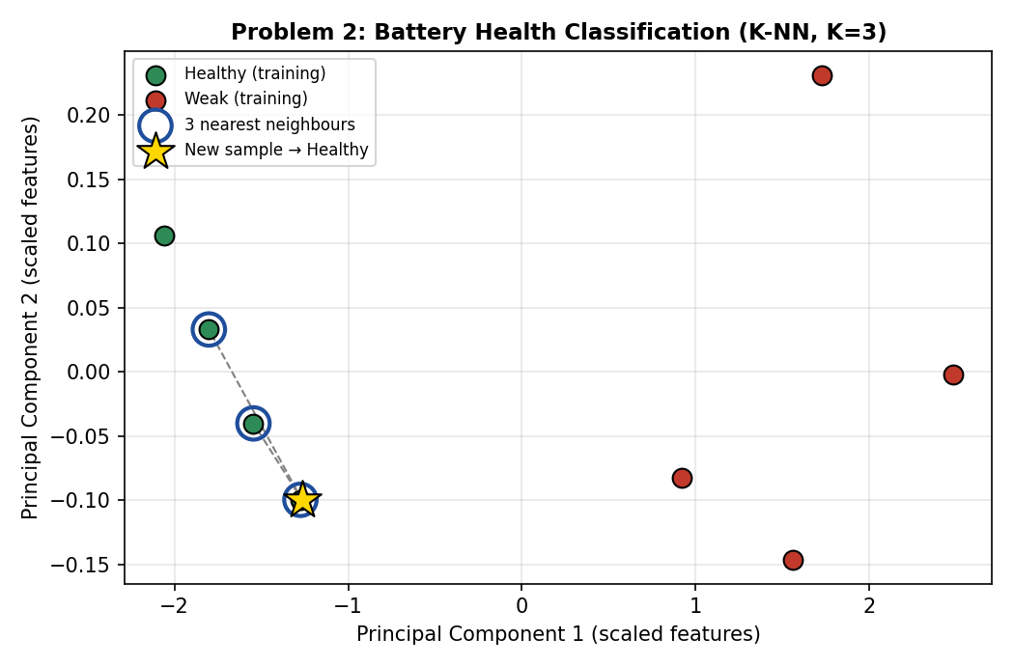
RESULT
Thus, the K-Nearest Neighbours algorithm was successfully implemented and the given battery sample was classified as Healthy.

PROBLEM 3: ROAD SURFACE CONDITION CLASSIFICATION
AIM
To implement the K-Nearest Neighbours (K-NN) algorithm in Python and classify a road surface as Safe or Rough using roughness index, vibration level and pothole count.
ALGORITHM
- Start the program.
- Import the required libraries.
- Create the road surface dataset.
- Define the input features and target classes.
- Standardize the feature values.
- Select K = 3.
- Train the K-NN classifier.
- Give the new road measurements as input.
- Calculate the distances between the new sample and training samples.
- Select the three nearest neighbours.
- Use majority voting to identify the class.
- Display the predicted road condition.
- Stop.
PROGRAM
import numpy as np
from sklearn.neighbors import KNeighborsClassifier
from sklearn.preprocessing import StandardScaler
X = np.array([
[2.0, 2, 0],
[2.5, 3, 1],
[3.0, 3, 1],
[7.0, 8, 5],
[8.0, 9, 6],
[6.5, 7, 4],
[2.8, 2, 1],
[7.5, 8, 5]
])
y = np.array([
"Safe", "Safe", "Safe", "Rough",
"Rough", "Rough", "Safe", "Rough"
])
scaler = StandardScaler()
X_scaled = scaler.fit_transform(X)
model = KNeighborsClassifier(n_neighbors=3)
model.fit(X_scaled, y)
new_sample = np.array([[3.0, 3, 1]])
new_scaled = scaler.transform(new_sample)
prediction = model.predict(new_scaled)
print("Predicted Class:", prediction[0])
INPUT
Roughness Index | Vibration | Potholes | Condition
2.0 | 2 | 0 | Safe
2.5 | 3 | 1 | Safe
3.0 | 3 | 1 | Safe
7.0 | 8 | 5 | Rough
8.0 | 9 | 6 | Rough
6.5 | 7 | 4 | Rough
2.8 | 2 | 1 | Safe
7.5 | 8 | 5 | Rough
New Sample: [3.0, 3, 1]
OUTPUT
Predicted Class: Safe
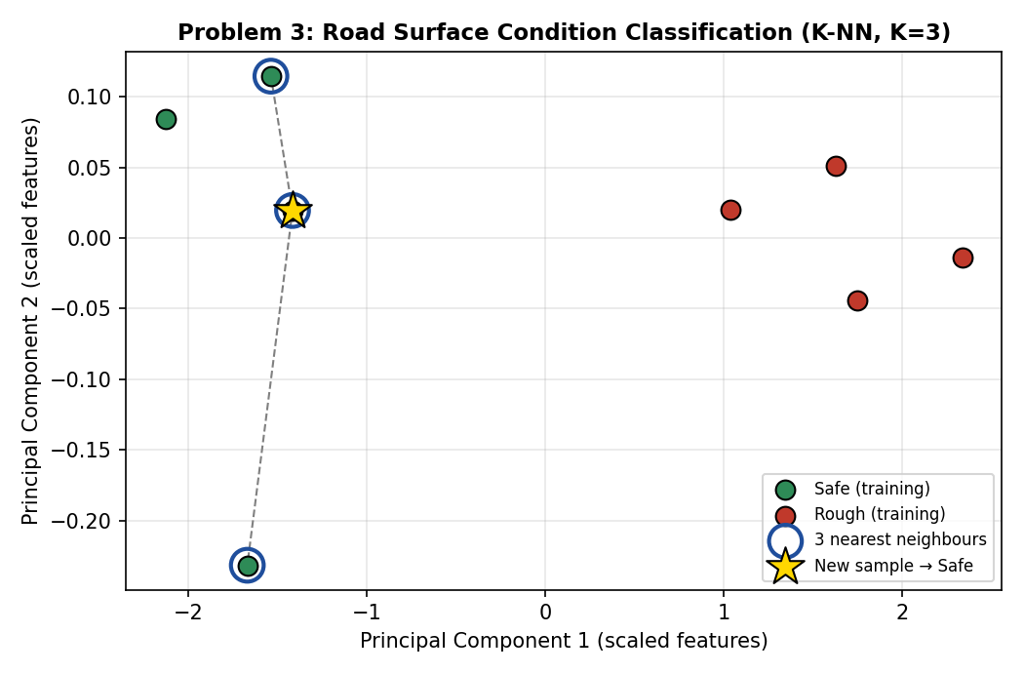
RESULT
Thus, the K-Nearest Neighbours algorithm was implemented successfully in Python and the given road sample was classified as Safe.

PROBLEM 4: CLASSROOM ENGAGEMENT CLASSIFICATION
AIM
To implement the K-Nearest Neighbours (K-NN) algorithm in Python and classify classroom engagement as High or Low based on attendance, participation and assignment completion.
ALGORITHM
- Start the program.
- Import the required Python libraries.
- Create the classroom engagement dataset.
- Separate the input features and target class.
- Standardize the feature values.
- Choose K = 3.
- Train the K-NN classifier.
- Enter the new student's details.
- Calculate the distance from the new sample to the training samples.
- Select the three nearest neighbours.
- Apply majority voting.
- Display the predicted engagement level.
- Stop.
PROGRAM
import numpy as np
from sklearn.neighbors import KNeighborsClassifier
from sklearn.preprocessing import StandardScaler
X = np.array([
[90, 8, 95],
[85, 7, 90],
[95, 9, 100],
[65, 3, 60],
[70, 4, 65],
[60, 2, 55],
[88, 8, 92],
[68, 3, 62]
])
y = np.array([
"High", "High", "High", "Low",
"Low", "Low", "High", "Low"
])
scaler = StandardScaler()
X_scaled = scaler.fit_transform(X)
model = KNeighborsClassifier(n_neighbors=3)
model.fit(X_scaled, y)
new_sample = np.array([[87, 7, 90]])
new_scaled = scaler.transform(new_sample)
prediction = model.predict(new_scaled)
print("Predicted Class:", prediction[0])
INPUT
Attendance (%) | Participation (10) | Assignments (%) | Engagement
90 | 8 | 95 | High
85 | 7 | 90 | High
95 | 9 | 100 | High
65 | 3 | 60 | Low
70 | 4 | 65 | Low
60 | 2 | 55 | Low
88 | 8 | 92 | High
68 | 3 | 62 | Low
New Sample: [87, 7, 90]
OUTPUT
Predicted Class: High
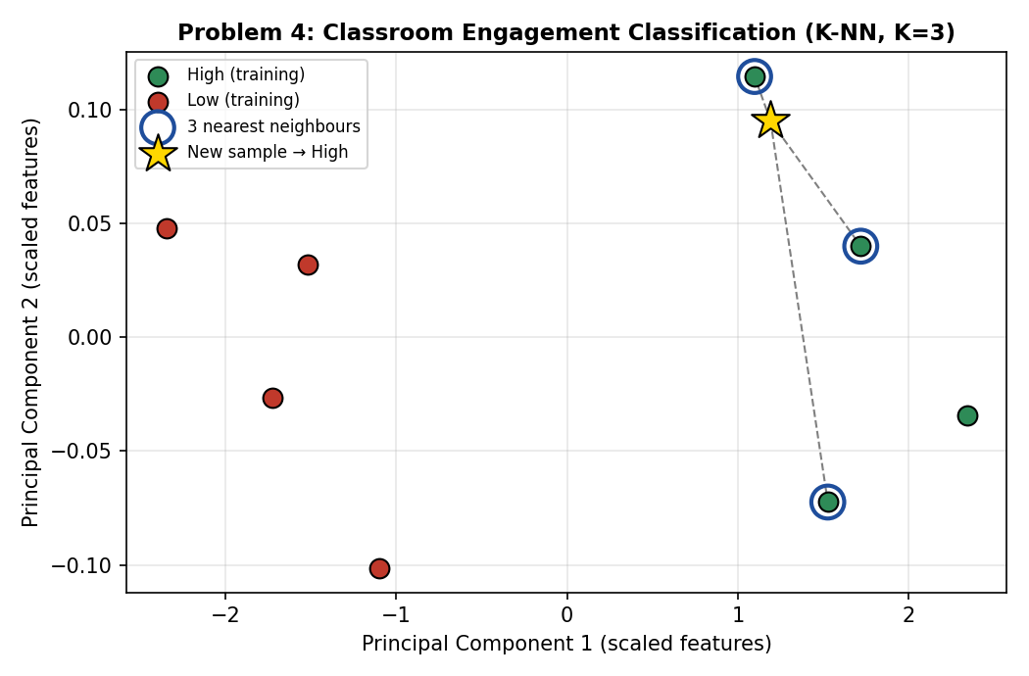
RESULT
Thus, the K-Nearest Neighbours algorithm was implemented successfully in Python and the given student's classroom engagement was classified as High.

PROBLEM 5: SMARTPHONE USAGE PATTERN CLASSIFICATION
AIM
To implement the K-Nearest Neighbours (K-NN) algorithm in Python and classify smartphone usage as Moderate or Heavy based on daily screen time, number of apps used and notification count.
ALGORITHM
- Start the program.
- Import NumPy, K-NN and StandardScaler.
- Create the smartphone usage dataset.
- Separate the input features and target class.
- Standardize the input features.
- Select K = 3.
- Train the K-NN classifier.
- Enter the new smartphone usage values.
- Calculate the distance between the new sample and training samples.
- Select the three nearest neighbours.
- Determine the class using majority voting.
- Display the predicted usage pattern.
- Stop.
PROGRAM
import numpy as np
from sklearn.neighbors import KNeighborsClassifier
from sklearn.preprocessing import StandardScaler
X = np.array([
[2.0, 8, 35],
[2.5, 10, 45],
[3.0, 12, 50],
[6.0, 25, 120],
[7.0, 30, 150],
[8.0, 35, 180],
[2.8, 11, 48],
[6.5, 28, 135]
])
y = np.array([
"Moderate", "Moderate", "Moderate", "Heavy",
"Heavy", "Heavy", "Moderate", "Heavy"
])
scaler = StandardScaler()
X_scaled = scaler.fit_transform(X)
model = KNeighborsClassifier(n_neighbors=3)
model.fit(X_scaled, y)
new_sample = np.array([[2.7, 11, 45]])
new_scaled = scaler.transform(new_sample)
prediction = model.predict(new_scaled)
print("Predicted Class:", prediction[0])
INPUT
Screen Time (hr) | Apps Used | Notifications | Usage
2.0 | 8 | 35 | Moderate
2.5 | 10 | 45 | Moderate
3.0 | 12 | 50 | Moderate
6.0 | 25 | 120 | Heavy
7.0 | 30 | 150 | Heavy
8.0 | 35 | 180 | Heavy
2.8 | 11 | 48 | Moderate
6.5 | 28 | 135 | Heavy
New Sample: [2.7, 11, 45]
OUTPUT
Predicted Class: Moderate
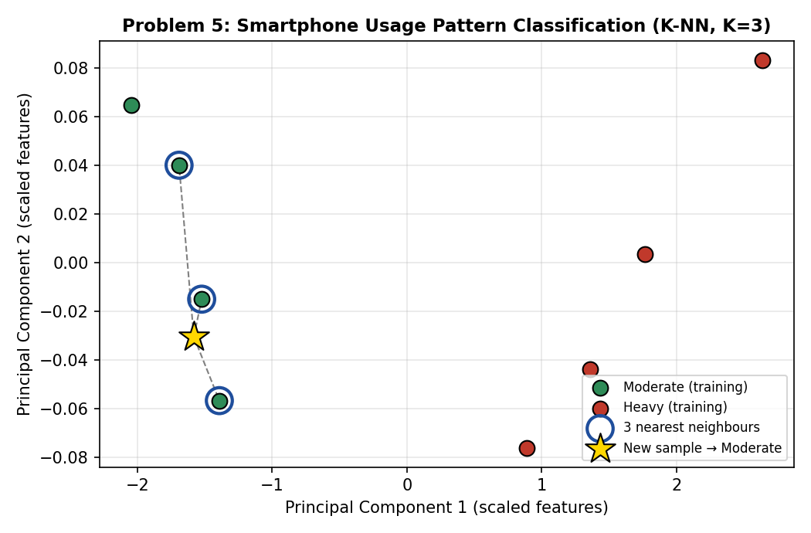
RESULT
Thus, the K-Nearest Neighbours algorithm was successfully implemented in Python and the given smartphone usage pattern was classified as Moderate.

